ANNUAL REPORT FOR 2023
 | 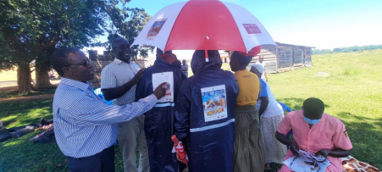
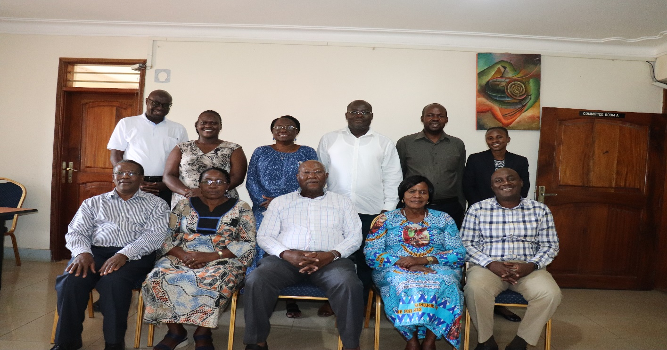

ACRONYMS

AIDS | Acquired Immune Deficiency Syndrome
AMS | Alive Medical Services
ART | Anti-Retroviral Therapy
BMC | Bushenyi Medical Centre
CAF | Children’s AIDS Fund
CAF I | Children’s AIDS Fund International
CAFU | Children’s AIDS Fund Uganda
CDC | Centers for Diseases Control and Prevention
FHCJ | Family Hope center Jinja
FHCK | Family Hope Center Kampala
HIV | Human Immune deficiency Virus
IDI | Infectious Disease Institute
IHFs | Indigenous Health Facilities
KCRC | Kabwohe Clinical Research Center
KHP | Kampala Regional HIV Project
NA | Nurture Africa
NESHU | National Expansion for Sustainable HIV/TB services in Uganda
NFSC | Namugongo Fund for Special children
NGO | Non-Government Organisation
OVC | Orphans and Vulnerable Children
PAFC | Positive Action Fund for Children
PEPFAR | President’s Emergency Plan for AIDS Relief
PMTCT | Prevention of Mother to Child Transmission
RHITES-EC | Regional Health Integration to Enhance Services East Central
SP | Strategic Plan
SUFA SABA | Support the Family and Save the Baby (SUFA-SABA)
TASO | The AIDS Support Organisation
TB | Tuberculosis
US | United States
USAID | United States Agency for International Development
UGX | Uganda Shillings
ViiV | ViiV Health Care

Executive summary
Children’s AIDS Fund Uganda (CAFU) continues to deliver comprehensive HIV services through evidence-based approaches, targeting underserved and vulnerable populations in hard-to-reach districts of Uganda. Our efforts, guided by a family-centered approach, focus on prevention, care, and treatment services, with particular emphasis on orphans and vulnerable children (OVC), adolescent girls, and key populations.
This report highlighted a number of successes as well as challenges and important lessons moving forward. For instance, the 2019-2023 strategic plan expired and a new strategic plan was drafted that will span 2024 -2028.There was a transition of USAID/CDC/IDI to Reach out Mbuya CDC/ROM) Kampala HIV project (KHP) in October 2023.The funding stream had reduced tremendously due to the enactment of the Anti-Homosexuality Bill into law; thus impacting programming and staffing of CAFU.
Despite all these challenges , CAFU continued to run the three projects namely Kampala HIV Project through Kampala Family Hope Clinic, the local service delivery Activity funded by USAID/UPMB/LSDA and VIIV health care being implemented in Ruvuma. The implementation of all the projects maintained CAFU’ family centered model that revolves on the family as a unit of health problems identification and design of local solutions for the local challenges.
The key results during the reporting period included
- A total of 18170 people were reached with HTS whom 261 people tested positive and were linked to care at the respective health facilities.
- CAFU interventions maintained 19921clients under care by the reporting period with an average viral load suppression rate of 97% from all the three sites.
- Only less than 2% of the clients tested positive for TB and consequently started on TB treatment while on ART
- Other highlights included the BoD retreat which shaped the development of the new strategic plan and reviewed the organizational audit report for the year 2023.
- The executive Director showcased the progress of VIIV Health Care project in Buvuma at the international conference on AIDS and STIs in Africa (ICASA) in Zimbabwe.

Contents
ACRONYMS ii
Executive summary iii
Introduction 1
2.0 Progress on the Performance 2
2.1. HTS Performance and Yield 2
2.0 Treatment Outcomes 3
2.1. Treatment outcomes at FHCK 4
2.2 USAID LSDA/UPMB/CAFU PROJECT SUMMARY PERFORMANCE FY3 OCT-2022-SEPT 2023 5
2.2.1. Uganda Virus Research Institute and EAPoC_VL Study 5
2.3. VIIV HEALTH CARE (SUFASABA PLUS) 6
3. CAFU Governance 11
4.0 Finance and Administration 11
5.0 Lessons and promising Practices 12
5.1 Promising Practices 12
5.0. Challenges 12
6.0. Recommendation 12

Introduction

Children’s AIDS Fund Uganda (CAFU) was established in 2002 and formally registered in 2005 with the Uganda National NGO Board registration number S.5914/5933 and now registered with the NGO Bureau Number INDR59333085NB. In 2019, CAFU adopted a new strategic plan with a revised Vision as” A healthy and productive HIV free population” and the revised Mission “To create an enabling environment for families to access comprehensive integrated HIV and priority health services through promotion of sustainable development approaches for a healthy and productive population in Uganda and beyond.”

The strategic plan 2019/2020-2023/2024 has five interactive goals that are essential for the achievement of the CAFU mission and vision;

- Strengthening Institutional Capacity for CAFU to achieve its mission and ensure Quality of Services
- Improved access to HIV/AIDS and healthcare services for infected and affected individuals, families, and communities through family centered approaches
- To establish and strengthen operational research capacity for continuous quality improvement for health service delivery
- To provide skills and capacity development for other organizations in similar business based on lessons learnt and changing service delivery environments
- To provide integrated and sustainable health services including improving livelihoods among households

Although CAFU envisions expansion and transition of the strategic goals into program areas. The advent of COVID has interrupted some of the efforts. However, deliberate efforts will continue to be made to expand the scope of the current HIV/AIDS programs, integrate HIV/AIDS with other programs (e.g. nutrition, ASRH, and child and maternal health), operational research as well as gradually and steadily addressing the challenging socio-economic components. This report is guided by the funded projects and reflects project achievements against set targets.

CAFU employed both the facility and community-based models to provide HIV Prevention and Treatment as well as OVC services through its 3 facilities; Family Hope Centre Kampala (FHCK), Family Hope Centre Jinja (FHCJ) and Namugongo Fund for Special Children (NFSC) in Wakiso. The community-based arm was greatly impeded by the COVID 19 pandemic.

Despite the pandemic, CAFU registered 100% patient Retention in care and treatment under all the age bands adults, adolescents and key populations. Elimination of mother to child transmission was a key highlight of the year at 99% with No positive PCR at the age 18 months of graduation. However OVC activities were muted under Covid 19 lock down restricting community services. Nonetheless, innovations including bike riders that provided medicines to patients at home and client follow up electronically with call reminders ensured continued care.

2.0 Progress on the Performance

2.1. HTS Performance and Yield

During the reporting period, CAFU reached out to a total of 18170 people with HTS in the three project sites and below is the distribution of the numbers with respective yields

Figure 1: HTS performance and yield from all the project sites
The catchment population under the LSDA/FHCJ was higher than the rest of the project sites and rigorous HIV testing and counselling were undertaken during the reporting period. While the VIIV health care project covers the whole district of Buvuma, there were several movements of people in between islands but also migration to other districts and islands and thus affecting the overall HTS performance. The changes in leadership and funding at FHCK contributed to performance.
Overall, HTS positives were not very many in all sites, an indication of the effectiveness of various efforts by CAFU and other agencies/Actors in the respective project sites.
Despite the USAID/CDC/IDI project transition to Reach out Mbuya (ROM) implemented through Family Hope Clinic Kampala, CAFU performance for 2023 of COP23 under the Kampala-Regional Mechanism for Accelerating and Sustaining Epidemic Control in the Republic of Uganda through PEPFAR; reached 3484 individuals with HIV testing services through its FHCK clinic achieving 53% against the last quarter’ target with a yield of positives (3.7%).
Although the absolute numbers were higher, the achievement is down on the previous quarter Q2 of 57 % due a new higher target. All the HIV positive clients identified were linked to care at FHCK and initiated on treatment. CAFU continues to strengthen its HTS strategies of community outreaches and partnerships with private local health facilities and risky population
Through community outreaches and other clinics 178 clients were diagnosed with TB and started on treatment. This was generated from both FHCK and FHCJ project sites.

2.0 Treatment Outcomes
CAFU interventions maintained 19921clients under care by the reporting period with an average viral load suppression rate of 97% from all the three sites. The bring back to care campaigns and the new enrollment from HTS and intensified follow up on clients led to an increase in clients numbers. Under the DSDMs, Clients continued to receive individualized or group specific services as well as ART drug pick up from drug distribution facilities in the communities.
These metrics included 880 CALHIV from Buvuma during the reporting period. This was attained through strengthened client retention, adherence counselling, client pre-appointment reminders and use peer groups. In addition, the facility community collaboration teams (FCCT) have been instrumental in identifying LTFU of clients and CALHIV
The annual achievement by individual project were as reflected below:

2.1. Treatment outcomes at FHCK
There were some increases among the clients in care and treatment (3666 and 585) compared to 3623 &585) quarterly targets for KFHC and NFSC respectively during the reporting period . These performance was attributed to the back to care campaigns and the new enrollment from HTS and intensified follow up on clients
Under the DSDMs, Clients continued to receive individualized or group specific services as well as ART drug pick up from drug distribution facilities in the communities. FHCK had 3494 (95%) clients classified as stable which is an improvement from 94% in Q2 while at NFSC stable clients were 71% from the 65% in Q2. This is as a result of ongoing adherence counseling and peer support.

Figure 2 Treatment outcomes

2.2 USAID LSDA/UPMB/CAFU PROJECT SUMMARY PERFORMANCE FY3 OCT-2022-SEPT 2023
FOR COP YR 3 (OCT 2022- SEPT 2023) different targets were assigned in different thematic areas by our partners UPMB. GEND_GBV among PLHIV, HTS_Testing, HIV Recency testing verification, HTS_SELF_Testing, TX_NEW (Newly enrolled clients), TX_CURR (Active clients in Care), PMTCT (STAT (Negative), ART, EID), Cervical cancer screening of HIV Positive eligible women, TB (STAT, ART, PREV) and Viral load as seen in table below.
Table 2: LSDA/UPMB/CAFU PROJECT SUMMARY PERFORMANCE FY3 OCT-2022-SEPT 2023

Indicator | Targets (COP Y3) | OVERALL ACHIVEMENT | % Achievement
GEND_GBV | 56 | 66 | 118%
HTS_TST | 13531 | 7675 | 57%
HTS_TST_POS | 524 | 121 | 23%
YIELD (%) |  |  | 1.6%
RECENCY TESTING | 121 | 73 | 60.3%
HTS_SELF_TST | 983 | 866 | 88%
TX_NEW | 524 | 122 | 23%
LINKAGE (%) |  | 109
TX_CURR | 4087 | 3909 | 95.6%
PMTCT_STAT | 2805 | 209 | 7%
PMTCT_ART | 154 | 69 | 45%
PMTCT_EID | 164 | 63 | 38%
CXCA_SC | 591 | 365 | 62%
CXCA_TX | N/A | 7
TB_STAT | 157 | 155 | 99%
TB_ART | 52 | 29 | 56%
TB_PREV | 225 | 136 | 60%
TX_PVLS (N) | 3795 | 3506 | 92%
TX_PVLS (D) | 3948 | 3559 | 90%

2.2.1. Uganda Virus Research Institute and EAPoC_VL Study
East African Point of Care Viral Load Study (EAPoC_VL Study) was implemented in several sites in Uganda. Its CAFU/FHCJ being on of the control sites in the study. The study mainly targeted non-supposed children and adolescents living with HIV at the sites. 43 Study participants of non-supposed were to be enrolled, to be followed up at 6 and 12 months.
All the 43 participants have been enrolled and 42 have been followed up both in Jinja and Kampala. The project is expected to end in August 2024.

2.3. VIIV HEALTH CARE (SUFASABA PLUS)
The HIV testing services were carried out at all the 12 sites in Buvuma considering the target population of the project who were the children living with HIV (CALHIV). CAFU works with 116 Facility Community Collaboration Teams (FCCTs) including the male champions, TBAs, young mentors, LC1's peer mothers and Health workers to enhance HIV testing, care linkage, and retention and Community Drug (ART) Distribution (CDD) in far islands for children and adolescents living with HIV (CALHIV).
During the reporting period there was an improvement in HIV testing among children and adolescents from 3096 in PY1 (June22 --May23 to 4471 (June 23-Mar 2024). Out of the 4471 tested, 38 children and adolescents were supported and linked to HIV treatment and care as compared to 63 of the previous year. This was attributed to the project interventions through targeted index testing, integrated community and school outreaches, youth friendly corner meetings, and male engagement dialogues which were used to identify this new cases.
According to DHIS2, 154 out of 182(85%) CALHIV who had up to date viral load test results had suppressed. A total of 218 CALHIV were active in care and accessing ART services as per the quarterly trends of the reporting year.

Figure 3 HTS among children and adolescents of different age bands in Buvuma
Currently 38 of the 40 identified children and adolescents were counseled, linked to care, and integrated into youth corner activities where they meet with fellow peers to overcome stigma and embrace positive living.
More female children and adolescents between the age bands of 15-19 years were tested .This was attributed to the effects of COVID 19 where most of the female pupils dropped out and were engaged in pre sexual activities as was reported by the FCCTs.

Figure 4.HTS BY AGE BANDS
Through different project interventions as young peers conducted home visits and supported CDD using their project provided bicycles, youth corners; which helped them address gaps that young people have been facing and limiting them to attend to care.
In a ploy to improve suppression rates, 76 households with CALHIV were identified and linked in to IGAs and VSLAs orientation and support to enhance their livelihood and foster adherence to ART and viral load suppression over the reporting period
12 nutritional dialogues and cooking demonstrations from the project sites reached 148 heads of households of CALHIV and HIV positive pregnant mothers with nutritional and cooking demonstrations. 85% of CALHIV in care are now suppressing. The activities aimed at creating knowledge, skills and information on using local available foods for better nutrition for their Children and adolescents on ART to support their adherence on ART and suppression. From the current suppression rate, of 85% its evident that caregivers were able to adopt the new skills and information regarding food preparation for support of the CALHIV on ART.

During the reporting period, the total of 2130 deliveries were recorded at the project facilities and 104 of these were to HIV positive women as of Jun 23- Fed 24. 11 infants from EID were linked to care over the reporting period. This was attributed to the FCCT approach of TBAs and peer mothers referring pregnant mothers to health facilities for HTS, ANC and other services, continuous follow up is being conducted through PMTCT and EID services as indicated by Fig 5
Success story of the TBAs in Buvuma
Strengthening Ties with Health Workers: Through training and orientation, Traditional Birth Attendants (TBAs) have developed a strong understanding of their roles in the referral system and HIV services at health centers. This has fostered mutual respect between TBAs and health workers, boosting the confidence of TBAs. As a result, TBAs actively encourage pregnant women to visit health centers for antenatal care (ANC) and HIV testing, which has improved community trust in government health facilities and increased the uptake of healthcare services.
Peer Engagement for Better Health Outcomes: TBAs have also taken it upon themselves to engage and educate their peers, spreading awareness about the importance of referring pregnant and breastfeeding mothers to health centers for HIV testing. This community mobilization has led to a rise in the number of women accessing healthcare services, which in turn has helped identify new HIV cases among children and adolescents, ensuring early treatment.
Direct Support to Pregnant Women and HIV-Affected Children: In addition to referrals, TBAs provide hands-on support by escorting pregnant women to health centers for testing and follow-up care. On Lwajje Island, one TBA ensures that HIV-positive women and their children receive ongoing care through the Prevention of Mother-to-Child Transmission (PMTCT) services. In some cases, TBAs have taken in HIV-positive children abandoned by their parents and, through their involvement in income-generating activities, continue to support these children’s health and well-being.

District Health Information System

Figure 5: Maternal Health indicators and HIV in Buvuma

It was noted that much as the 1st ANC was higher throughout the year, there was an increasing trend of supervised deliveries at the health centers which gave chance for increased EID services and follow up.
76 households were selected, oriented and provided information on business skills and financial literacy.
Other achievements over the reporting period included the representation and presentation on the progress of SUFASABA project at the international conference on AIDS and STIs in Africa (ICAS) by the Executive Director.
SUFA SABA Plus project is an expansion of SUFA SABA project that was implemented January 2020 – May 2022 at 4 Health Centres in 4 sub-counties of Buvuma Island District
SUFA SABA Plus is building on the gains of SUFA SABA project which increased access to HTS, ANC, PNC services from 492 in 2020 to 1098 in 2022; reduced community deliveries from 41% to 13%; and EID Cascade with timely PCR increased from 29 to 125 at the end of project. The district maternal indicators for HIV shifted from the RED zone to GREEN.

This success was attributed to the Facility community collaboration Team (FCCT) composed of two peer mothers, two health Care workers and one traditional birth attendant at each of the four project sites.
The SUFA SABA Plus is:The geographical expansion from the four sub counties to the entire district an expressed wish of all stakeholders led by the district leadership;
The increase in service package and target population to include children and adolescents living with HIV (CALHIV)
The expansion of the FCCT to include male champions, young mentors, local area leadership (LC1s ) in addition to the peer mothers, traditional birth attendants and health workers.
Following the ICAS conference an operational research was launched to determine the functionality and effectiveness of the facility community collaboration teams in the SUFASABA Plus project in Buvuma district.

Key SUFASABA PLUS activities highlighted by ED during the ICAS conference in Zimbabwe- Dec 2023

The ED also show cased the performance outcomes on the health system indicator arising from implementation of the SUFA SABA PLUS Project in Buvuma as in the figure below
An RFA was issued on CAFU website and contractor commissioned to conduct an implementation research on the functionality and effectiveness of the facility community collaboration teams in Buvuma

3. CAFU Governance
CAFU board remained active throughout the year and reviewed and approved management plans, budgets reports and financial audits. The board also resolved on the new strategic direction for CAFU during its end of year retreat. Emphasis was put on organization visibility expansion of CAFU’ scope of work, mandate and resource mobilsation through the new strategic plan

Retreat proceedings | CAFU new strategic direction for the year 2024-2028
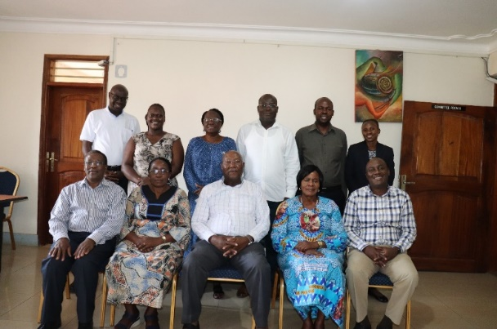 | 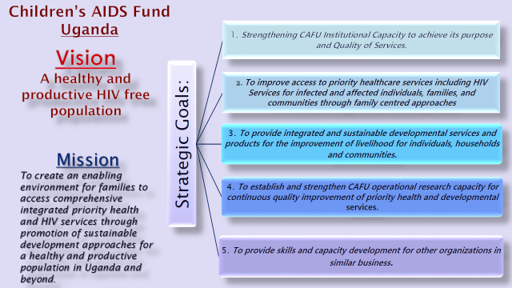
CAFU Board and some management members during the Retreat

4.0 Finance and Administration
Over the reporting period, CAFU was successfully audited with un qualified report. Please see the CAFU’ finance and audited report of 2023
Despite the limited success, efforts for resource mobilization and grant making were made to different donors such as EU, PMI MRA and others. CAFU applied and successfully submitted 4 proposals and reached out to TASO, MUWREP, Uganda AIDS Commission and Ministry of Health for support.
The four applications were as follow:
Table 2 Grant making and resource mobilization
 | Donor | Project proposal | Remarks
1 | AIDSFONDS | A Healthy Future for Children and their Young Mothers living with or exposed to HIV | Not funded
2 | PMI MRA | Malaria control in eastern Uganda | Not funded
3 | European Commission | Reducing Teenage pregnancy by building social economic resilience for young women and adolescents in Uganda | Not funded
4 | USAID Integrated children and youth development(ICYD), | Readiness and soft skills training and transitional support for youth aged 15-29years. | No response
5 | ICT CREATIVES COMPANY | Shared CAFU profile for collaboration | Not yet

5.0 Lessons and promising Practices
The continued engagement of the DHOs office has ensured coordination of FCCTs activities at the facilities by the HCWs. This has allowed capturing referral data at the facility that is informing our implementation efforts. District departments/Officials with responsibility in our interventions are fully supportive including DHO, DCDO, Production, DEO not to mention the senior Political and Administrative officers.
Involvement of district stakeholders in performance review meetings has revealed that there are other key issues that need to be addressed within and outside the project scope. We are now have close working relationship with the main District developmental partner MUWRP.

5.1 Promising Practices
- Intensifying home based counselling and testing activities by the peers, CLFs and expert clients
- Engaging community peers and male champions to mobilize for HTS activities.
- Sensitizing clients about SNS, APN/ index testing strategies and home-based counselling testing through health talks.
- Engage and support community health facility to do targeted HTS and link positive clients to our facilities.

5.0. Challenges
- The changing and dwindling funding landscape due to the anti-homosexuality law and consequently reducing the scope of operation of CAFU.
- The change in disease epidemiology from infectious to noninfectious and re-emerging infections requires well-funded policy shifts to cope with the current issues
- High water transport costs from islands to health facilities often lead to poor clinic attendances or missed appointments with poor treatment outcomes. Moreover, the youths from flung off islands cannot attend youth corner activities where support is available. The Social and Economic Empowerment officer left CAFU affecting the Project IGA and VSLA

6.0. Recommendation
- CAFU should intensify resource mobilization to cope with the changing funding land scape
- Cafu should increase engagement with likeminded organizations and agencies to synergize and jointly apply for grants
- Scaling up partnership AND collaboration with other companies, organizations and agencies

